**Critical Thinking 6**

Alastair A. Ohde

Colorado State University Global

CSC 372-1

Vanessa Cooper

May 25, 2025

package CSC372;

public class Student {  //This is a file that will return the student's information and rollno

    int rollno;

    String name;

    String address;

    public Student(int rollno, String name, String address) {  //Defines student

        this.rollno = rollno;

        this.name = name;

        this.address = address;

    }

    @Override

    public String toString() {

        return "Student [rollno = " + rollno + ", name = " + name + ", address = " + address + "]";

    }

}

package CSC372;

import java.util.Comparator;

public class NameComparator implements Comparator<Student> {  //This file returns the compared students names

    @Override

    public int compare(Student s1, Student s2) {

        return s1.name.compareTo(s2.name);

    }

}

package CSC372;

import java.util.Comparator;

public class RollnoComparator implements Comparator<Student> {  //This file returns the compared students rollno

    @Override

    public int compare(Student s1, Student s2) {

        return s1.rollno - s2.rollno;

    }

}

package CSC372;

import java.util.ArrayList;

import java.util.Comparator;

public class SelectionSort {  //This file is a custom selection sort method

    public static <T> void sort(ArrayList<T> list, Comparator<? super T> comparator) {

        int n = list.size();

        for (int i = 0; i < n - 1; i++) {

            int minIndex = i;

            for (int j = i + 1; j < n; j++) {

                if (comparator.compare(list.get(j), list.get(minIndex)) < 0) {

                    minIndex = j;

                }

            }

            T temp = list.get(minIndex);

            list.set(minIndex, list.get(i));

            list.set(i, temp);

        }

    }

}

package CSC372;

import java.util.ArrayList;

public class Main {  //This file runs the program, returning the students information in three ways: The original list, list sorted by names, and list sorted by rollno

    public static void main(String[] args) {

        ArrayList<Student> students = new ArrayList<>();

        students.add(new Student(5, "James", "Charles Town"));

        students.add(new Student(10, "Eggbert", "Martinsburg"));

        students.add(new Student(3, "Simon", "Ransom"));

        students.add(new Student(7, "Ulysses", "Charleston"));

        students.add(new Student(4, "Sylvestor", "Clarksburg"));

        students.add(new Student(9, "Morton", "Morgansburg"));

        students.add(new Student(1, "Sheldon", "Beckley"));

        students.add(new Student(6, "Vinton", "Harpers Ferry"));

        students.add(new Student(8, "William", "Fairmont"));

        students.add(new Student(2, "Carl", "Priceton"));

        System.out.println("Original List:");  //Returns unaltered list

        System.out.println(students);

        System.out.println("\nSorted by Name:");  //Returns list sorted by names

        SelectionSort.sort(students, new NameComparator());

        System.out.println(students);

        System.out.println("\nSorted by Roll Number:");  //Returns list sorted by rollno

        SelectionSort.sort(students, new RollnoComparator());

        System.out.println(students);

    }

}

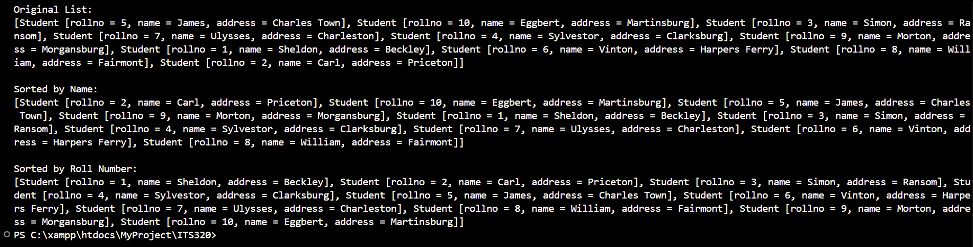

https://github.com/Ebberous/CSC320-1-Critical-Thinking